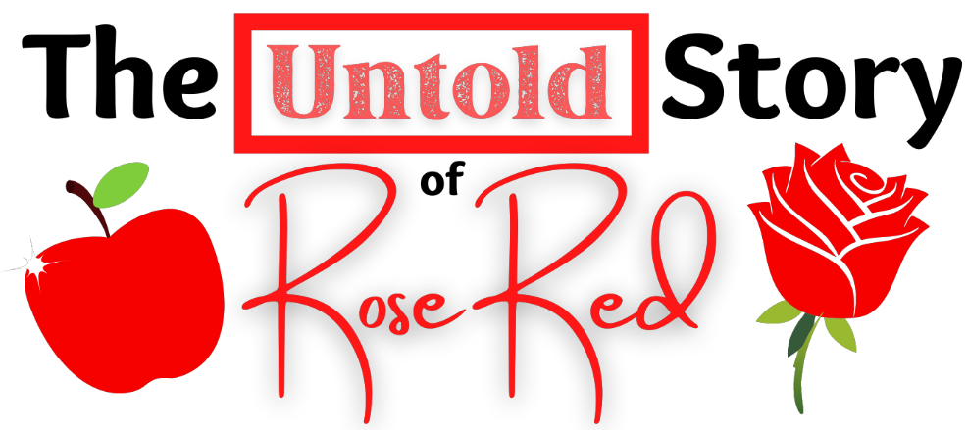

CHARACTER DESCRIPTIONS

SNOW WHITE, sugary sweet teen princes.

MAMA BEAR, motherly reporter for the Ursine Times.

BABY BEAR, hard-hitting young reporter for the Ursine Time.

MOTHER, of Snow White and Rose Red.

YOUNG SNOW WHITE, a younger version of herself.

YOUNG ROSE RED, our unsung hero at a younger age.

GRANNY, grandmother of Snow White and Rose.

WOODCUTTER, woodcutter who loves trees.

COWBOY, Village Person, as in one of the Village People.

CONSTRUCTION WORKER, another Village Person, as in one of the Village People.

POLICE OFFICER, another Village Person, as in one of the Village People.

BIKER, another Village Person, as in one of the Village People..

FIRST NATIONS REPRESENTATIVE, another Village Person, as in one of the Village People..

WOLF, big, bad – you know the routine.

REPORTER ONE, on-the-scene journalist.

REPORTER TWO, another on-the-scene journalist.

REPORTER THREE, another on-the-scene journalist.

ROSE RED, at age sixteen.

JACK, “cool” kid in love with Snow White.

SECURITY AGENT, very vigilant about his job.

JACK’S MOM, an exhausted mother.

SUGAR, a talkative teen cow; Spice’s BFF.

SPICE, another teen cow; Sugar’s BFF.

WILMA DAVIS, bean merchant.

SHERIFF OF NOTTINGHAM, searching for Robin Hood; might be looking in the wrong story.

LITTLE JANE, tall, determined daughter of Mother Hubbard; good with a quarterstaff.

CRIER TUCK, a little pig.

MAD MARIAN, another little pig.

FESTUS, one more little pig.

Gleeful Gals

JILL SCARLET, Southern belle.

ALANA DALE, minstrel.

GEORGIA GREENE, unenthusiastic.

BEETLE, Georgia’s brother.

MUCH, miller’s daughter.

MORE, another miller’s daughter.

MAS, one more miller’s daughter.

