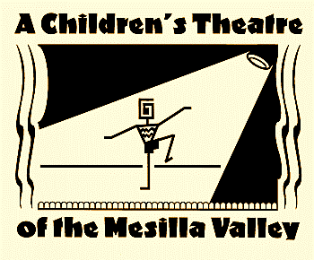

Complete and mail form with payment to:   
ACT: PO Box 1792, Las Cruces, NM 88004

**CIRCLE ONE:**

**Acting Skills Workshop $75**

**April 6th-April 9th, 4:00-5:30pm**

Student’s Name__________________________________________________________

Student’s Grade_______School_____________________________________________

Teacher’s Name If Student is K-5____________________________________________

Parent’s Name(s)_________________________________________________________

Address________________________________________________________________

Phone Number__________________________Cell_____________________________

Email__________________________________________________________________

**Is email a good way to reach you?** Yes No, please contact me here_______________ _______________________________________________________________________

**Does your child have allergies:**  Yes No If yes, please describe: _________________

**More information call/text 575 571-1413, email act@zianet.com**