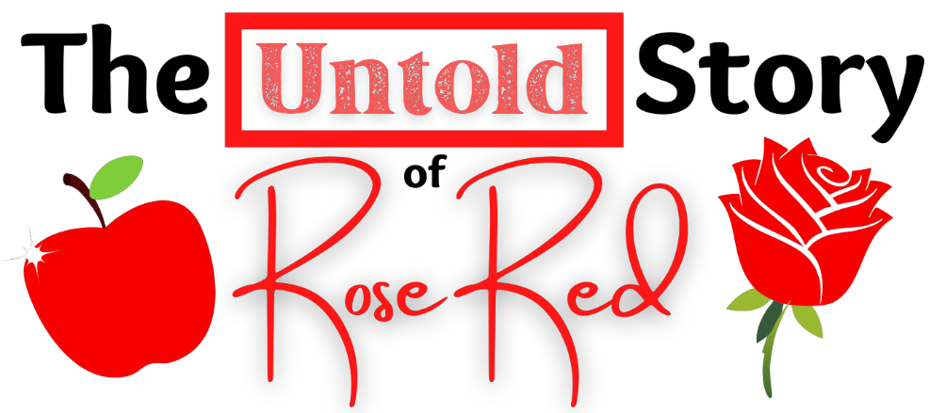

Synopsis

Sugary sweet media darling Snow White thinks her fair sister, Rose Red (aka Little Rose Red Riding Hood of Sherwood Forest), never gets the credit she deserves. To set the record straight, Snow invites reporters Baby Bear and Mama Bear to give them the real scoop: Rose Red is no helpless victim or weak-kneed witness — she’s the hero!
Comical flashbacks come to life as Snow regales reporters with a series of stories about Rosie. Featuring fun storybook, fairytale, and pop culture cameos — from the Village People and bean-loving Jack Sprat to nefarious villains like the Sheriff of Nottingham and Big Bad Wolf — Rosie has the help of her “Gang of Gleeful Gals” (think “Merry Men,” only female and more fierce) to send the villains packing and save the surrounding villages! Touched by her sister’s efforts, Rosie assures Snow that being a hero isn’t all about accolades — sometimes it’s enough just to be admired by those who matter most.
This storybook and fairytale crossover comedy celebrates sisterhood, girl power, heroism, and affirmation.

