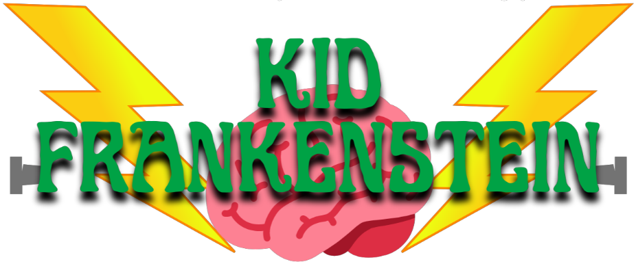

CHARACTER DESCRIPTIONS

The Students

FRANKIE STEIN, kid scientist, counterpart to Dr. Frankenstein.

IRVING, Frankie’s best friend, counterpart to Igor.

HELGA, principal’s daughter, counterpart to Elizabeth Lavenza.

ABIGAIL, one of school kids, storytellers and villagers.

DARRYL, another of the school kids, storytellers and villagers.

JAYDEN, another of the school kids, storytellers and villagers.

MEGAN, another of the school kids, storytellers and villagers.

SHAWNA, another of the school kids, storytellers and villagers.

ZACH, another of the school kids, storytellers and villagers.

T-BONE, ringleader of the kid troublemakers and villager.

BARBIE Q, one of the kid troublemakers and villagers.

CLEAVER, another of the kid troublemakers and villagers.

KNUCKLEHEAD, another of the kid troublemakers and villagers.

N.M. SKULL, another of the kid troublemakers and villagers.

RIBEYE, another of the kid troublemakers and villagers.

The Adults

MRS. NEWTON, science teacher, counterpart of Dr. Waldman.

MR. KLONDIKE, principal, counterpart of Herr Vogel.

MR. SPOTS, crazy and creepy zookeeper.

MRS. MAGILLACUTTY, old and nearsighted neighbor of Mrs. Newton.

The Phenomenon

MONSTER, invention of Frankie, Irving and Helga.

