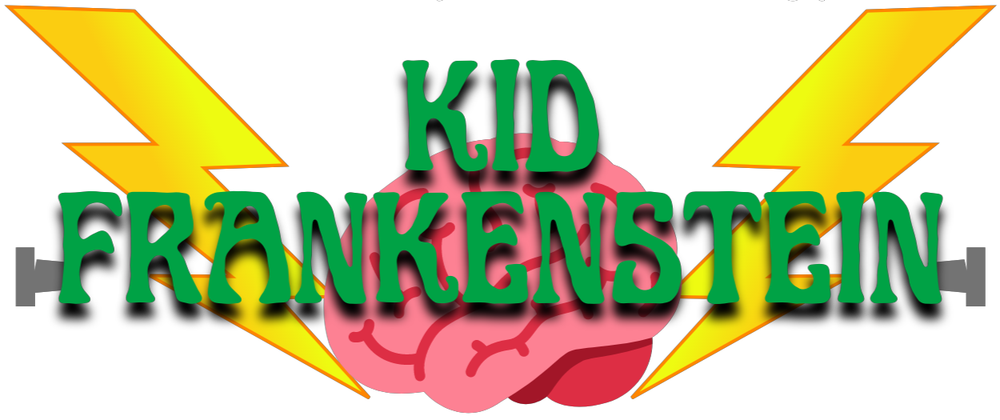

Synopsis

Frankie and Irving are science nerds who have an unusual idea for the upcoming Science Fair! When Doctor Frankenstein's ancient secret book arrives from Transylvania, the friends are whisked into a sci-fi fantasy of time-warped, weirdly scary and lively adventure!
Frankie needs a brain for his new monster! Irving and Helga sneak into the science lab to grab a monkey brain but it gets mixed up with the brain of little Fluffy, a sweet puppy dog. Hilarity ensues as Frankie and his crew present a surprising monster to the Science Fair!
Troublemakers T-Bone and his Gang of Bonez try to ruin Frankie's plans even as the Monster terrifies the Villagers. Science Teacher Mrs. Newton comes to the rescue. Only she can stop the terrible brain transference! Villagers storm the kids' basement laboratory just in time for nutty Principal Klondike to restore order. The lovable Monster is returned to his owner and everyone lives happily ever after!

