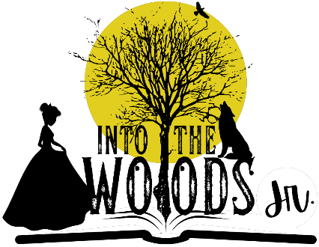

CAST LIST
CHARACTER NAME | CAST
NARRATOR | Austin Pruett
JACK | Julian Castro
BAKER | Jonah Ocampo
CINDERELLA’S STEPMOTHER / RAPUNZEL | Katy Graham
LUCINDA / CINDERELLA’S MOTHER | Marisol Lujan
LITTLE RED RIDINGHOOD | Miranda Miller-Tomlinson
WOLF / CINDERELLA’S FATHER | Braden Gonzales
CINDERELLA’S PRINCE | Bryce Rexroth
MILKY-WHITE | Sara Biad
CINDERELLA | Kayla Bradford
JACK’S MOTHER | Lucy White
BAKER’S WIFE | Lily Graham
FLORINDA / GRANNY | Nalani Lujan
WITCH | Maya Bradford
MYSTERIOUS MAN | Brendan Strascina
RAPUNZEL’S PRINCE | Ashyre Rexroth
STEWARD | William Miller-Tomlinson

