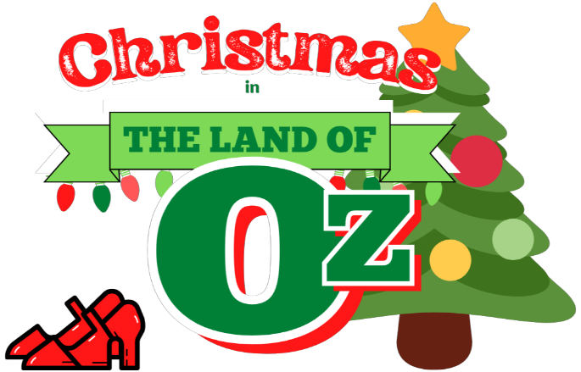

Synopsis

The Wicked Witch of the West becomes the grinch of this delightful holiday play when she steals Christmas from Munchkinland. It takes all your Oz favorites — Dorothy and Toto, Scarecrow, Tin Man, the Lion, and the Munchkins to bring the yuletide holiday back. In the process, the Tin Man recovers his sense of humor, the lonely Lion finds a lady companion, and Dorothy finds the spirit of Christmas to take back to Kansas for Auntie Em and Uncle Henry.

