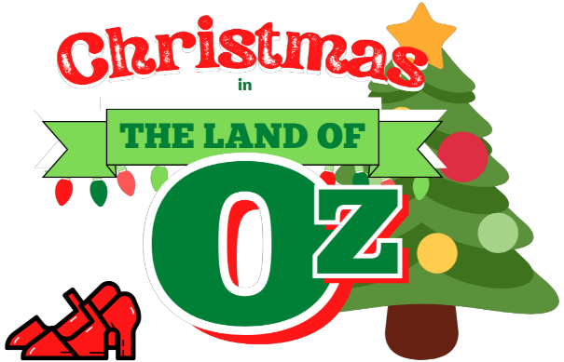

CHARACTER DESCRIPTIONS

Kansans

AUNT EM, hasn’t had any time for Christmas, has completely forgotten that the day is near.

DOROTHY GALE, feels the same way about Christmas and long to return to OZ find it.

TOTO, Dorothy’s dog, actually speaks like Scooby-Doo.

UNCLE HENRY, very busy with chores, but still does his best to try to make his niece happy.

Witches

WICKED WITCH, of the Northwest, similar to the Wicked Witch of the West, but not the same.

GLINDA, Good Witch of the North, very sweet and kind with a bubbly personality.

WANDA JUNE, Good Witch of the South that would rather be a country singer, must be willing to sing.

Other Ozians

LION, brave, now due to his newfound courage, but still very lonely and sad.

TIN MAN, has a heart, but now has lost his sense of humor and finds nothing funny.

SCARECROW, the new leader of the Emerald City who is a great think and part-time rapper.

LADY LION, once a very famous movie star, but is now cursed by the Wicked Witch of the Northwest.

Munchkins

MAYOR, of the Munchkin City, in the County of the Land of Oz.

TOYMAKER, similar to an elf who makes all the toys for Christmas.

FEATHER, one of the munchkins who assists the toymaker.

MOONBEAM, another one of the munchkins who assists the toymaker.

BLOSSOM, another one of the munchkins who assists the toymaker.

Wanda June’s Roadies

CLEM, typical roadie with a very country and southern personality.

BILLIE JOE, another typical roadie with a very country and southern personality.

JIM BOB, another typical roadie with a very country and southern personality.

Winged Monkeys

CAPT. SIMIAN, the head of the Winged Monkeys, right-hand man of the Wicked Witch of the Northwest.

LT. CHIMP, second in command of the Winged Monkeys, works below Captain Simian.

SGT. APE, the third in command of the Winged Monkeys, works below Lt. Chimp.

